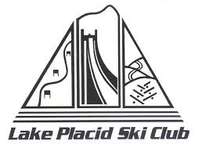
LPSC/NYSEF Ski Sale----Merchandise Check-in
NAME: _____________________________________________________________________________________
FULL ADDRESS: ___________________________________________________________________________
EMAIL: _______________________________________ PHONE: ____________________________________

TAG # | BRAND | Description- print clearly | SIZE | PRICE
Ex. 1 | Volkl | 2018 SL Ski | 152 | $250
LPSC and NYSEF each get 10% of commission on all sales
Conditions of Consignment Merchandise
- NYSEF, and its authorized agents reserve the right to reject any item.
- You will be paid 80% of the value for any items sold with a check in the mail within 2 weeks.
- Any unsold items must be picked up on Saturday, November 2 by Noon.
- Any unsold items not picked up will be donated.
- LPSC/NYSEF is not responsible for lost, misplaced or incorrectly tagged items.
______________________________________________________________
Customer signature

